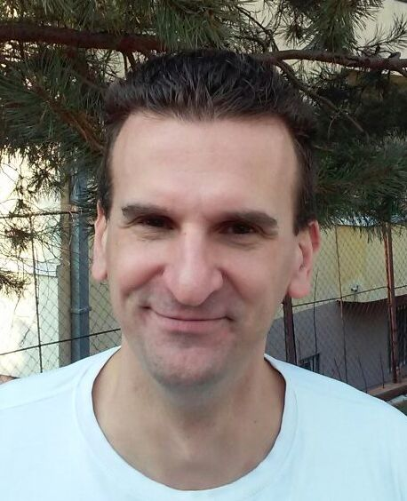

Srdja Tapušković

Mobile +381 60 6172-809
e-mail : srdjat@hotmail.com

Qualifications

- 20 years of teaching tennis professionally
- worked with players of all ages and abilities
- ran tennis programs at tennis clubs in the USA and Europe

Professional experience

-2013 – present Head assistant coach, Tennis Institute of Belgrade, Belgrade, Serbia
-2012 - present Head assistant coach “Topaco” tennis academy, Belgrade, Serbia
-2009-2012 Head assistant coach “Green Set” tennis academy, Belgrade, Serbia
-2007-2009 Assistant coach “Red Star” tennis club, Belgrade, Serbia
-2007-2009 Assistant coach “Sport Eko” tennis club , Belgrade, Serbia
-2007-2008 Assistant coach “Lokomotiva” summer junior tennis camps, Belgrade, Serbia
-2006-2007 Assistant coach “Tennis-tennis” tennis club, Belgrade, Serbia
-1994-1998 Assistant coach “Glastonbury Tennis Club” Glastonbury, Connecticut, USA
-1996-1998 Head Pro at Minnechaug Tennis Club, Glastonbury , Connecticut (Summer)
-1998-2001 Assistant Pro at Simsbury Tennis House and Canton Racquet Club (Simsbury, Canton, Connecticut, USA (Sister clubs))

Playing Experience

-ranked top 20 in all junior age groups in former Yugoslavia (all ex-republics)
-full tennis scholarship at University of Hartford, 1994-1998, Connecticut, USA (#1 doubles, #5 singles)

Education

1994-1998 Bachelor of Arts in Mathematics, University of Hartford, West Hartford, Connecticut, USA

